Leitura de PDF com SAP Data Servives

<https://pdfbox.apache.org/>

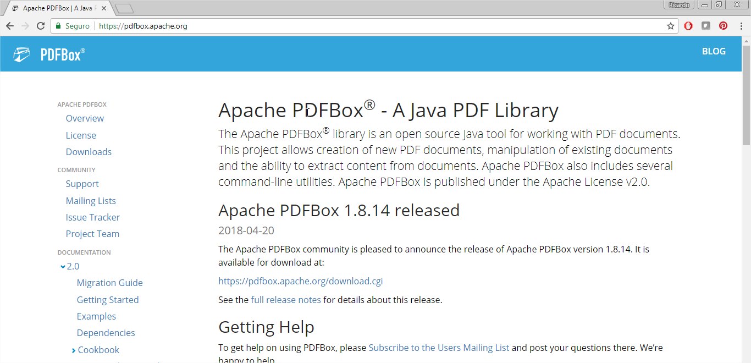

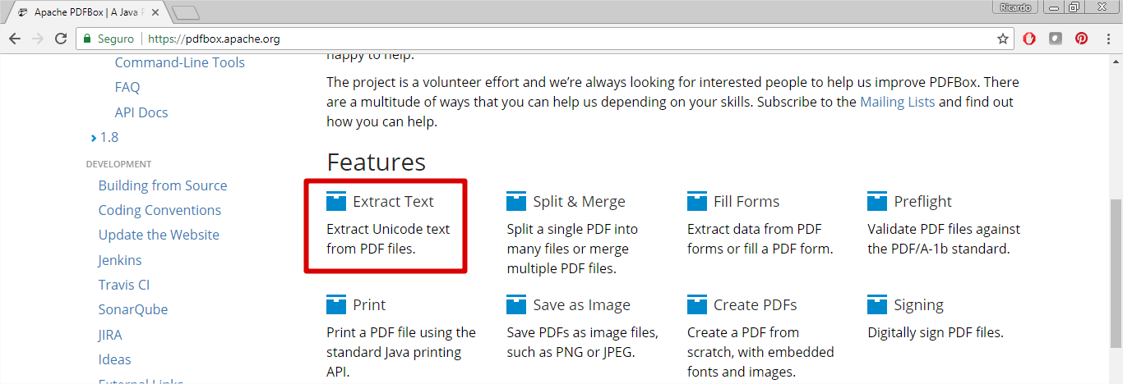

<https://pdfbox.apache.org/download.cgi>

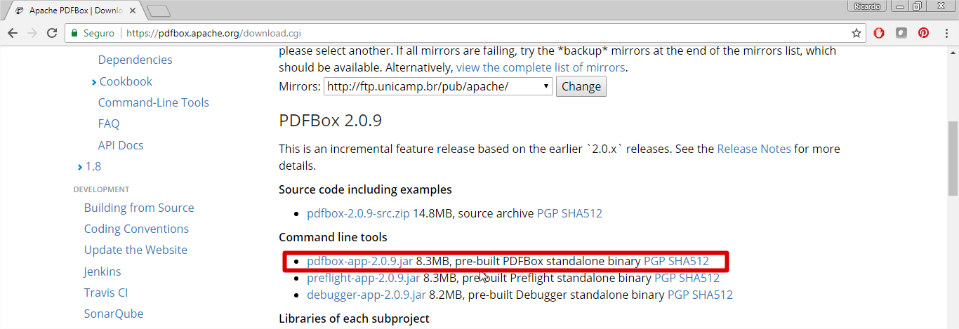



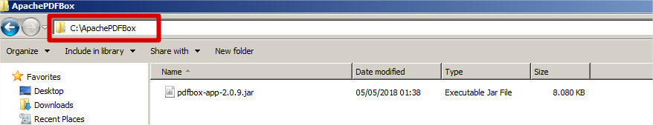

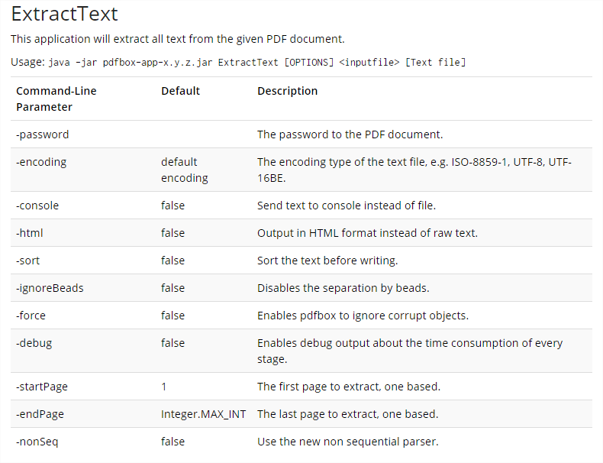

java -jar C:\ApachePDFBox\pdfbox-app-2.0.9.jar ExtractText -encoding ISO-8859-1 -sort -ignoreBeads -startPage 1 -endPage 1000 "C:\GestaoDePedidos\Impressao\PDF\Nr_Pedido_1_20180201.pdf" "C:\Nr_Pedido_1_20180201.txt"

